PLANT NETWORK AND CORPORATE NETWORK (DAY 1 OF INTERNSHIP)

In modern industrial environments, networks are generally divided into Plant Networks and Corporate Networks based on their functions and operational requirements.
A Plant Network is used in industrial environments such as factories, manufacturing plants, power plants, and production facilities. It connects operational technology (OT) devices like PLCs, SCADA systems, sensors, actuators, and industrial control systems that monitor and control physical processes. The main focus of a plant network is reliability, real-time communication, safety, and continuous operation. Any network interruption can directly affect production or industrial processes.
Since any interruption can directly affect manufacturing operations, equipment performance, or worker safety, network availability and stability are considered the highest priorities. Plant networks typically use specialized industrial communication protocols and are designed to operate with minimal downtime.

A Corporate Network, on the other hand, is designed for business operations and connects employee computers, servers, printers, email systems, databases, and internet services. It supports functions such as communication, data sharing, enterprise applications, and business management. The primary goals of a corporate network are productivity, data security, and efficient information exchange.
SECURITY :
In terms of security, plant networks are usually isolated or segmented from corporate networks because industrial systems often require high availability and may use specialized protocols. Corporate networks typically have stronger internet connectivity and are exposed to common cybersecurity threats such as phishing, malware, and unauthorized access. Organizations often implement network segmentation and firewalls to securely separate plant and corporate networks while allowing controlled data exchange between them.
Another significant difference is in their security requirements. Corporate networks are more exposed to external threats due to internet connectivity, while plant networks are protected through strict network segmentation, firewalls, and controlled access mechanisms. For this reason, organizations usually separate plant and corporate networks while allowing secure data exchange between them when necessary.
In summary, a plant network is designed to support industrial operations and process control, whereas a corporate network is designed to support business operations and information management. Both networks serve different purposes but work together to ensure the efficient and secure functioning of an organization.

Advantages of OT Networks

1- Real-Time Control: OT networks are intended to offer real-time control and visibility, which is mandatory for secure and sensitive industrial processes.

2-Reliability: OT systems are constructed to be resilient and fail safe so that it will continue running for extended durations without halting.

3-Customization: Major OT networks are thus designed and developed uniquely to meet the requirements of several industrial processes.

Advantages of IT Networks
1-Scalability: IT networks are highly flexible and can accommodate a fast growing business from the small business to the large business.

2-Flexibility: IT networks are very adaptable to variety of applications such as cloud computing, artificial intelligence among others.

3-Integration: All the IT networks are required to incorporate other technologies and platforms to enhance the compatibility of the network and to share the data.

What is IT in a Plant?
IT supports:
- Production monitoring
- Employee management
- SAP operations
- CCTV surveillance
- Biometric attendance
- Network communication
- Email and internet services

Major Systems in HURL
- SAP
- Network Infrastructure
- CCTV
- Biometric Access
- User Support
- Servers
- Internet Connectivity

DIAGRAM OF IT SYSTEMS IN FERTILIZER PLANT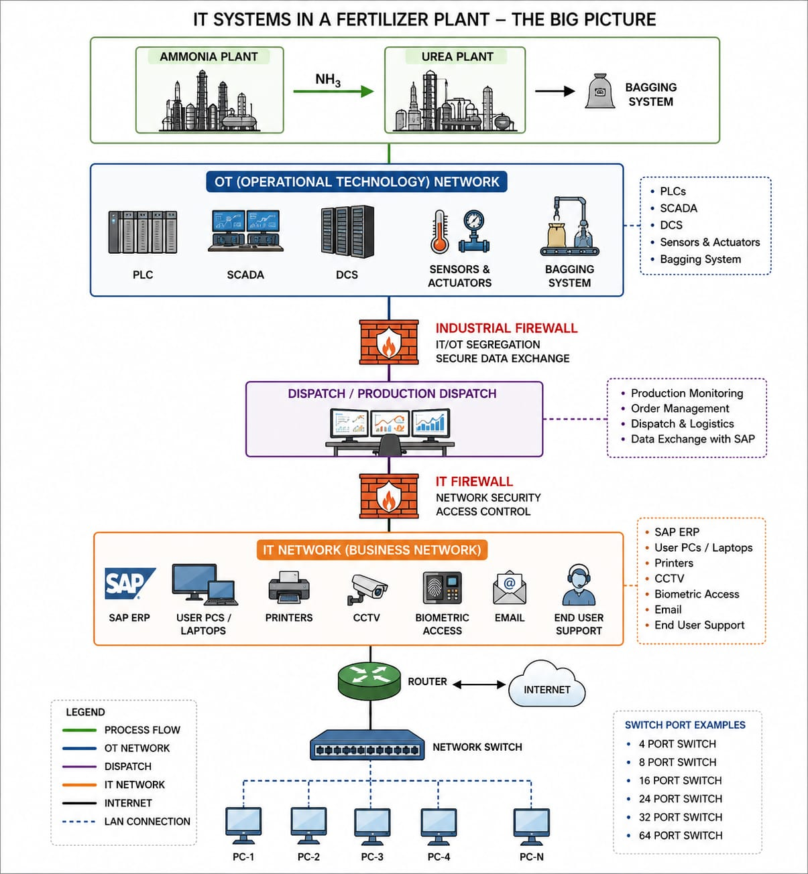
Explanation of Each Block
1. Production Process
Ammonia Plant
- Produces ammonia (NH₃).
- Raw material for urea production.
Urea Plant
- Uses ammonia to manufacture urea fertilizer.
Bagging Section
- Packs finished fertilizer into bags.
- Production data is monitored through PLC/SCADA.

2. OT (Operational Technology) Network
OT controls the actual plant operations.
Components
PLC (Programmable Logic Controller)
- Controls motors, pumps, valves.
- Receives signals from sensors.
SCADA
- Supervisory Control and Data Acquisition.
- Operators monitor plant status.
DCS
- Distributed Control System.
- Controls large industrial processes.
Sensors & Actuators
- Measure temperature, pressure, flow.
- Execute control commands.

3. Industrial Firewall
Purpose:
- Separates OT from IT.
- Prevents cyber attacks from reaching plant equipment.
- Controls data exchange.

4. Dispatch Section
Functions:
- Tracks finished goods.
- Manages shipment and logistics.
- Shares production data with SAP.

5. IT Network
Supports business operations.
SAP ERP
Used for:
- Production planning
- Inventory
- Purchase management
- HR
- Finance
End User Systems
- Laptops
- Desktop PCs
- Printers
Security Systems
- CCTV
- Biometric Access Control
Communication
- Email
- Internet Access

6. Router & Internet
Router connects:
- Plant network
- Corporate network
- Internet
Provides:
- Internet access
- Remote support
- Communication

7. Network Switch
Purpose:
- Connects multiple devices in LAN.
- Distributes network connectivity.
Examples:
- 8 Port Switch
- 16 Port Switch
- 24 Port Switch
- 48 Port Switch

Day 2 (SECOND HALF): Networking Fundamentals.
Network
A network is a collection of interconnected devices that communicate and share resources.
Types of Networks
LAN (Local Area Network)
A LAN covers a small geographical area such as:
- Office
- Building
- Laboratory
- Campus
Features:
- High Speed
- Low Cost
- Easy Maintenance
WAN (Wide Area Network)
WAN connects networks over large geographical distances.
Examples:
- Internet
- Corporate Networks
Features:
- Long Distance Communication
- Multiple Locations Connectivity

MAN (Metropolitan Area Network)
MAN covers a city or metropolitan area.
Examples:
- City-wide ISP Network
- University Network

OSI Model
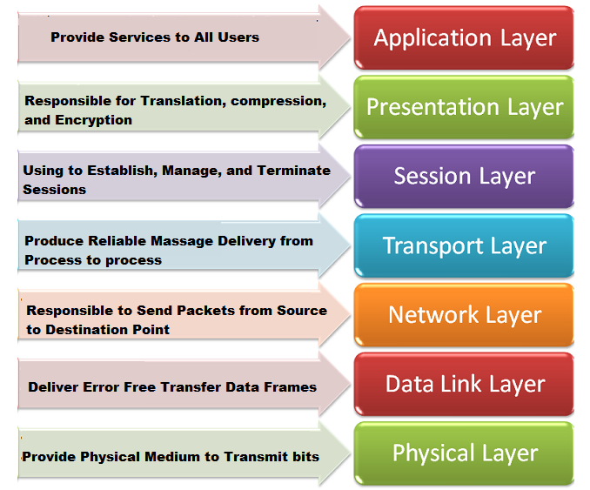

The OSI Model consists Physical of seven layers:
- Layer
- Data Link Layer
- Network Layer
- Transport Layer
- Session Layer
- Presentation Layer
- Application Layer
Purpose:
Provides a standard framework for network communication.

TCP/IP Model

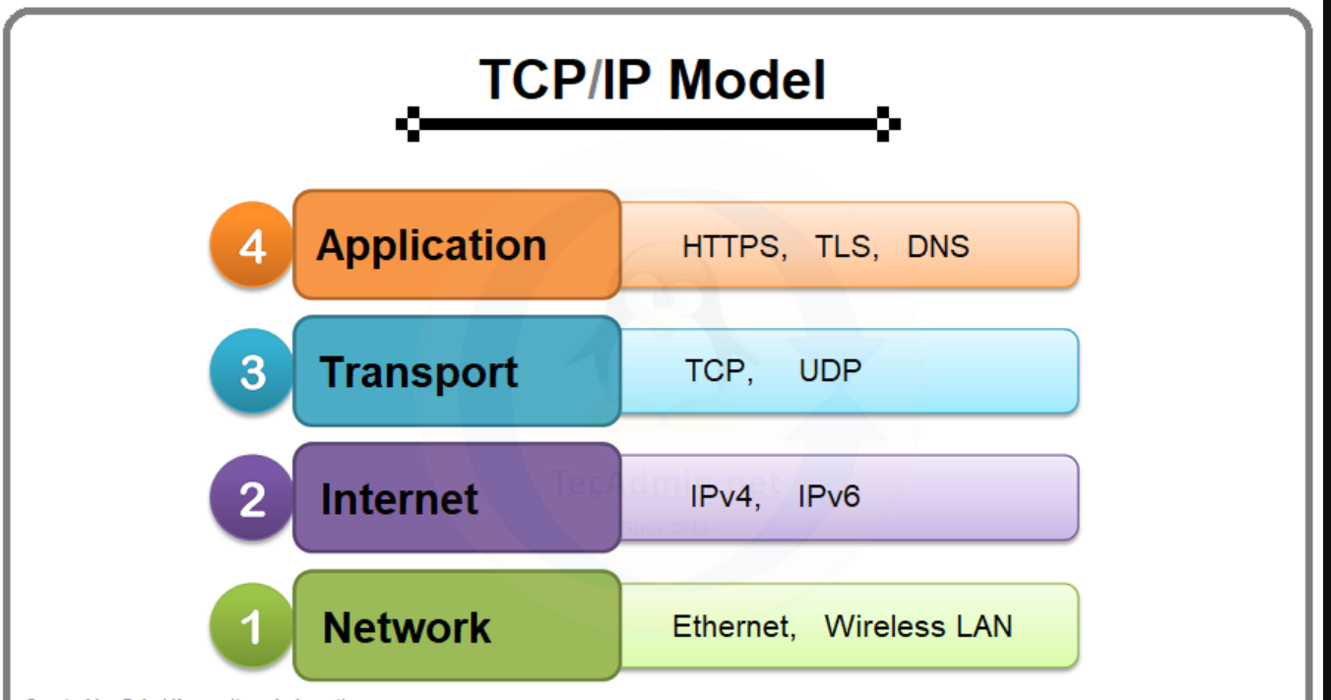

The TCP/IP model consists of:
- Network Access Layer
- Internet Layer
- Transport Layer
- Application Layer
Protocols:
- HTTP
- HTTPS
- FTP
- TCP
- UDP
- IP
- DNS

IP Addressing
An IP address uniquely identifies a device on a network.
Example:
192.168.1.10
IPv4 Address Structure
An IPv4 address contains:
- Network ID
- Host ID
Example:
192.168.1.10
Network Portion → 192.168.1
Host Portion → 10

Public and Private IP Addresses
Private IP Ranges
Class A:
10.0.0.0 – 10.255.255.255
Class B:
172.16.0.0 – 172.31.255.255
Class C:
192.168.0.0 – 192.168.255.255

DHCP (Dynamic Host Configuration Protocol)
DHCP automatically provides:
- IP Address
- Subnet Mask
- Default Gateway
- DNS Server
DHCP Process:
- Discover
- Offer
- Request
- Acknowledge
Benefits:
- Automatic Configuration
- Reduced Manual Work
- Centralized Management

DNS (Domain Name System)
DNS converts domain names into IP addresses.
Example:
www.google.com → IP Address
Functions:
- Name Resolution
- Faster Network Access
- User-Friendly Browsing

Subnetting

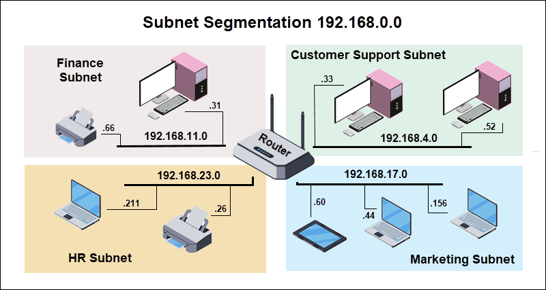
Subnetting is the process of dividing a large network into smaller networks.
Advantages:
- Better Security
- Reduced Broadcast Traffic
- Efficient Network Management
Example:
Network:
192.168.1.0/24
Subnets:
- 192.168.1.0/26
- 192.168.1.64/26
- 192.168.1.128/26
- IT VS OT COVERGENCE 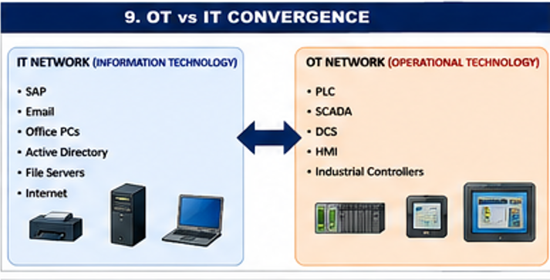
IT and OT convergence refers to the integration of enterprise networks with industrial control systems.
Benefits:
- Real-time Data Sharing
- Better Decision Making
- Centralized Monitoring
- Improved Productivity
- Industry 4.0 Implementation

- DAY 3 (INTERNSHIP)
Network Cables and Physical Connectivity
CAT6 Cable Types
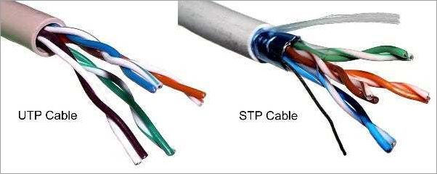

1. UTP (Unshielded Twisted Pair)
- No shielding
- Low cost
- Indoor use
- Most common Ethernet cable
Applications:
- Office LAN
- Computer Networks
- Printers

2. STP (Shielded Twisted Pair)
- Metallic shielding present
- Reduces electromagnetic interference (EMI)
- Used in industrial environments
Applications:
- Outdoor networks
- Factory networks
- High-noise areas
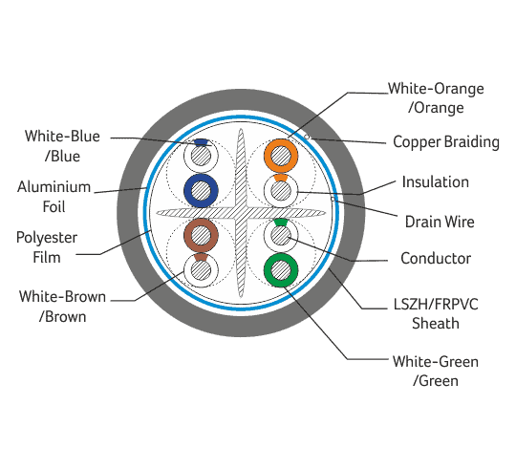
3. Armoured Cable
- Protective metal armour
- Used underground
- Expensive
- Resistant to physical damage
Applications:
- Underground networking
- Plant-to-plant connectivity

RJ45 Connector
RJ45 is the standard Ethernet connector used with CAT6 cables.
PC --------RJ45-------- Switch
Functions:
- Network connectivity
- Data transmission
- Ethernet communication

CAT6 Wiring Standards
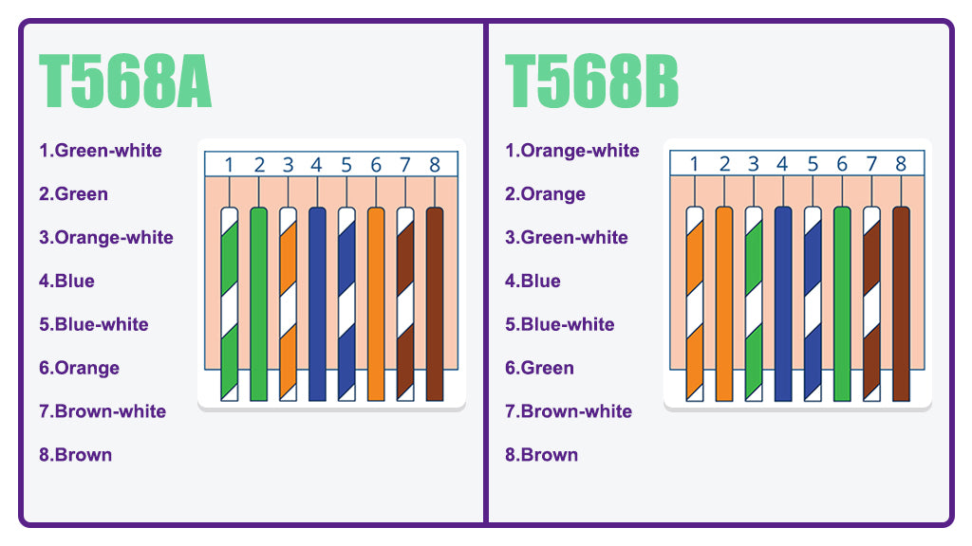
T568A
1 White-Green
2 Green
3 White-Orange
4 Blue
5 White-Blue
6 Orange
7 White-Brown
8 Brown

DIAGRAM:
--------------------------------
|WG|G|WO|B|WB|O|WB|BR|
--------------------------------
1 2 3 4 5 6 7 8

1 White-Orange
2 Orange
3 White-Green
4 Blue
5 White-Blue
6 Green
7 White-Brown
8 Brown

DIAGRAM:
--------------------------------
|WO|O|WG|B|WB|G|WB|BR|
--------------------------------
1 2 3 4 5 6 7 8
Straight Through Cable
Same standard on both ends.
T568B -------- T568B
Used for:
- PC to Switch
- Switch to Router

Cross Over Cable
Different standards on both ends.
T568A -------- T568B
Used for:
- PC to PC
- Switch to Switch (older devices)

DAY 6 – Switches and VLAN

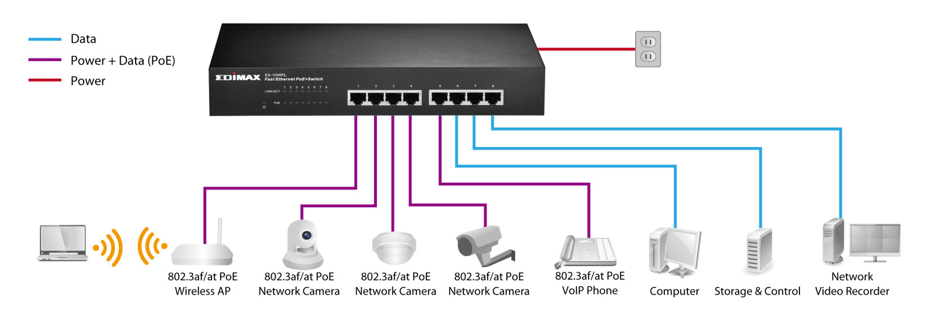
Network Switch
A switch connects devices within a LAN.
Types of Switches
1. POE Switch
Power Over Ethernet
Provides:
- Data
- Electrical Power
using a single Ethernet cable.
Applications:
- IP Cameras
- IP Phones
- Wireless Access Points

2. Non-POE Switch
Provides:
- Data only
Applications:
- PCs
- Printers
- General networking

Managed Switch
Features:
- VLAN configuration
- IP configuration
- Monitoring
- Port security
Example:
NETGEAR Managed PoE Gigabit Switch
Advantages:
- High control
- Better security
- Advanced configuration

Unmanaged Switch
Features:
- Plug and play
- No configuration
Advantages:
- Easy installation
- Low cost

Switch Speeds
Speed | Name
10 Mbps | Ethernet
100 Mbps | Fast Ethernet
1000 Mbps | Gigabit Ethernet
10000 Mbps | 10 Gigabit Ethernet

VLAN (Virtual Local Area Network)
Purpose:
Logical segmentation of a network.
Example:
VLAN 10 HR
VLAN 20 Finance
VLAN 30 CCTV
VLAN 40 OT
Benefits:
- Security
- Reduced broadcast traffic
- Better management

Access Port (Untagged Port)
Belongs to a single VLAN.
Example:
PC
|
Access Port
|
Switch
Characteristics:
- Single VLAN
- Untagged traffic

Trunk Port (Tagged Port)
Carries multiple VLANs.
Example:
Switch A
||
Trunk
||
Switch B
Characteristics:
- Tagged frames
- Multiple VLANs

Tagged Port
Contains VLAN ID in Ethernet frame.
Used for:
- Switch to Switch communication

Untagged Port
No VLAN tag.
Used for:
- End-user devices

VLAN DIAGRAM (WRITTEN JUSTIFICATION FOR EACH SEGMENT)

VLAN SEGMENTATION

CRIMPING
Crimping Procedure
- Cut CAT6 cable.
- Remove outer jacket.
- Arrange wires according to T568A or T568B.
- Insert wires into RJ45 connector.
- Crimp using crimping tool.
- Test cable using LAN tester.

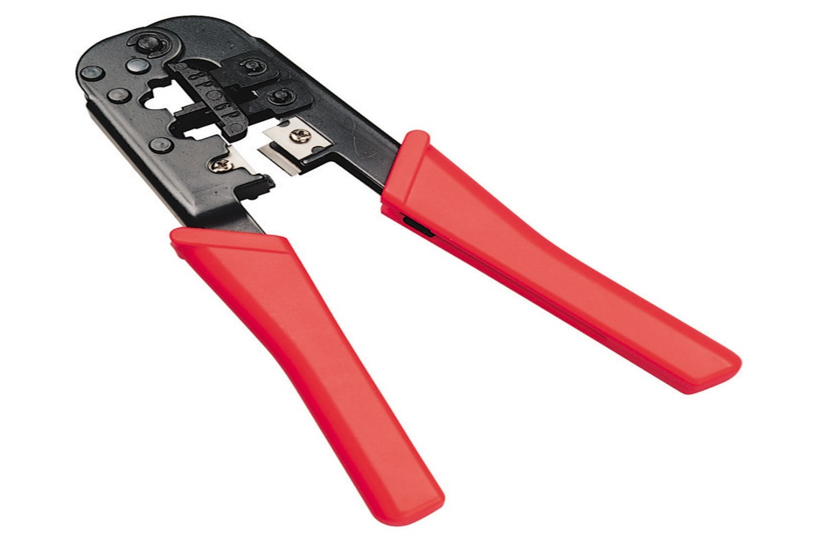
Crimping Tools Used
- Crimping Tool
- RJ45 Connector
- LAN Tester
- Wire Stripper
DAY 3 (SECOND HALF) – Practical Network Connectivity
This is a complete report section based on the practical activity your manager appears to have demonstrated.

Aim
To establish communication between two laptops using a network switch, configure static IP addresses manually, enable file sharing, verify connectivity, and perform network troubleshooting using Command Prompt commands.

Network Components Required
- Laptop A
- Laptop B
- Network Switch
- CAT6 Cable
- RJ45 Connectors

Network Topology
Laptop A
192.168.1.10
|
|
CAT6 Cable
|
|
NETWORK SWITCH
|
|
CAT6 Cable
|
|
Laptop B
192.168.1.11

Step 1 – Physical Connection
Connect both laptops to the switch using CAT6 cables.
Laptop A ---- Switch ---- Laptop B
LED indicators on the switch should glow.
Green LED = Link Active
Blinking LED = Data Transfer

Step 2 – Configure Static IP Address
Laptop A
Open:
Control Panel
↓
Network and Sharing Center
↓
Change Adapter Settings
↓
Ethernet
↓
Properties
↓
Internet Protocol Version 4 (TCP/IPv4)
Enter:
IP Address :
192.168.1.10
Subnet Mask :
255.255.255.0
Default Gateway :
192.168.1.1

Laptop B
Enter:
IP Address :
192.168.1.11
Subnet Mask :
255.255.255.0
Default Gateway :
192.168.1.1

Step 3 – Enable Network Discovery
Open:
Control Panel
↓
Network and Sharing Center
↓
Advanced Sharing Settings
Enable:
Network Discovery
Enable:
File and Printer Sharing
Save Changes.

Step 4 – Create Shared Folder
Create Folder:
Training
Right Click
Properties
↓
Sharing
↓
Advanced Sharing
Check:
Share this Folder
Give Permission:
Everyone
Read/Write
Apply.

Step 5 – Verify IP Configuration
Open Command Prompt.
Command:
ipconfig
Output:
IPv4 Address : 192.168.1.10
Subnet Mask : 255.255.255.0
Gateway : 192.168.1.1
Purpose:
Shows network configuration.

Step 6 – Test Connectivity Using Ping
From Laptop A:
ping 192.168.1.11
Expected Output:
Reply from 192.168.1.11
Bytes=32
Time<1ms
TTL=128
Meaning:
Laptop B is reachable.

ICMP Protocol
Ping uses:
ICMP
Full Form:
Internet Control Message Protocol
Functions:
- Connectivity Testing
- Error Reporting
- Reachability Testing
- Network Diagnostics

Step 7 – Continuous Ping
Command:
ping -t 192.168.1.11
Purpose:
Continuous monitoring.
Output:
Reply from 192.168.1.11
Reply from 192.168.1.11
Reply from 192.168.1.11
Stop:
Ctrl + C
Manager specifically mentioned:
ping -t
for continuous ping testing.

Step 8 – View ARP Table
Command:
arp -a
Purpose:
Displays mapping between:
IP Address
↓
MAC Address
Example:
192.168.1.11
AA-BB-CC-DD-EE-FF
Meaning:
System learned MAC address of Laptop B.

What is ARP?
ARP: Address Resolution Protocol
Purpose:
Converts:
IP Address
↓
MAC Address
Required for communication in LAN.

Step 9 – DNS Lookup
Command:
nslookup google.com
Output:
Server: dns.google
Name: google.com
Address: 142.xx.xx.xx
Purpose: Checks DNS resolution.

What is DNS?
DNS: Domain Name System
Purpose:
Converts: google.com into 142.xx.xx.xx

Step 10 – Trace Route
Command:
tracert google.com
Purpose:
Shows route taken by packets.
Example:
PC
↓
Router 1
↓
Router 2
↓
ISP
↓
Google

What is Hop?
Each router crossed is called:
Hop
Output Example:
Hop 1
192.168.1.1
Hop 2
ISP Router
Hop 3
Google

Step 11 – Check Network Adapter Details
Command:
ipconfig /all
Displays:
- IP Address
- MAC Address
- DHCP Status
- DNS Server
- Gateway

Step 12 – Verify Name Resolution
Command:
ping google.com
If DNS works:
Pinging google.com [142.xx.xx.xx]
Meaning:
DNS successfully resolved hostname.

